### Eyewire Beginner’s Guide For Excellence And Proper Tracing

Seung Lab Created - **May 2nd 2017**



**Table Of Contents**

Eyewire Beginner’s Guide For Excellence And Proper Tracing

What is eyewire?

Neuroanatomy

Soma

Axon

Dendrite

Basic Controls

Eyewire Expert Tips and Tricks

Filling in somas:

Duplicate Cubes

### What is eyewire?

Eyewire is a game to map the brain that originated at Sebastian Seung's Lab at MIT. This citizen science human-based computation game challenges players to map 3D neurons in a retina.

That’s what wikipedia says. More recently we have added an eyewire expansion set of sorts. (around June 2017) The new data can be accessed by qualifying players with seasoned abilities and will be open to all players eventually. This new data brings a clearer look into neuroanatomy revealing intracellular organelles. These new helpful anatomical clues can provide a deeper insight into understanding each neuron better and there by connecting them more accurately. Though these clues are helpful they are not without their own challenges. With greater clarity in the images brings more confusion to newer players. Let's go over some of the clues in effort to smooth out the rocky learning process. If you are already informed about the morphology and anatomy of the neuros then by all means use the table fo contents to jump to the basic controls section.

Let's talk about the basic neuron and all of it’s pieces. A neuron has a soma, and axon, and a dendrite. Given the data we have we will sometimes see a neuron that is missing one or two of these pieces. This is because those parts were not included in the imaging process or are otherwise unavailable to view at this time. For the sake of explanation though let's say we have all three.

### 

### Neuroanatomy

#### Soma

Let’s take a good look at a soma in 3D and 2D

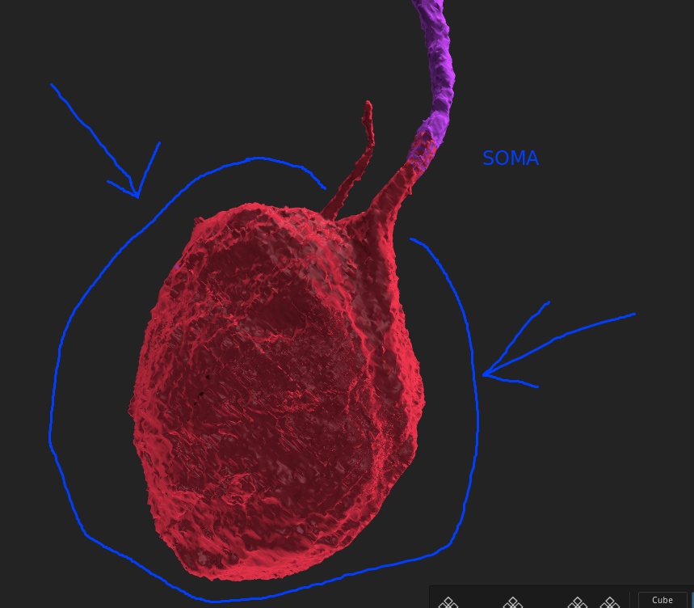

This is a 3D image of a [soma](https://en.wikipedia.org/wiki/Soma_(biology)). You can see it’s a large oval shaped ball with grooves and ridges and a smooth wavy surface. Sometimes there will be smaller protrusions coming off the soma in different directions. Their overall shape typically remains very similar though regardless of how many branches or processes are connecting to them.

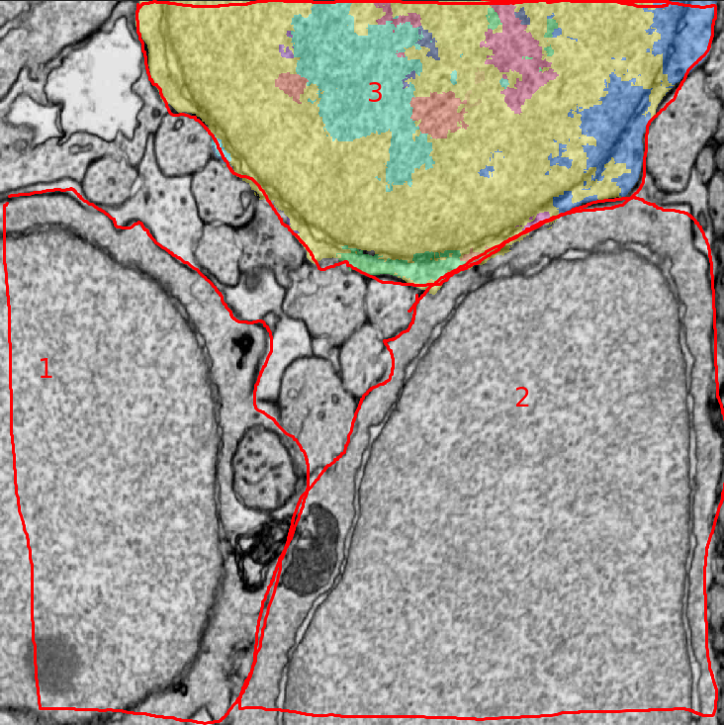

This is a 2D look into the Electron microscopy image (EM) of one of the planes axis. Here there are three soma labeled 1, 2, and 3. The soma labeled 3 is the one in the 3D picture above. Inside this image we are only able to see about half the soma. From these images you can tell that the somas are typically gigantic compared to their neurites. Next let’s look at Axons.

#### Axon

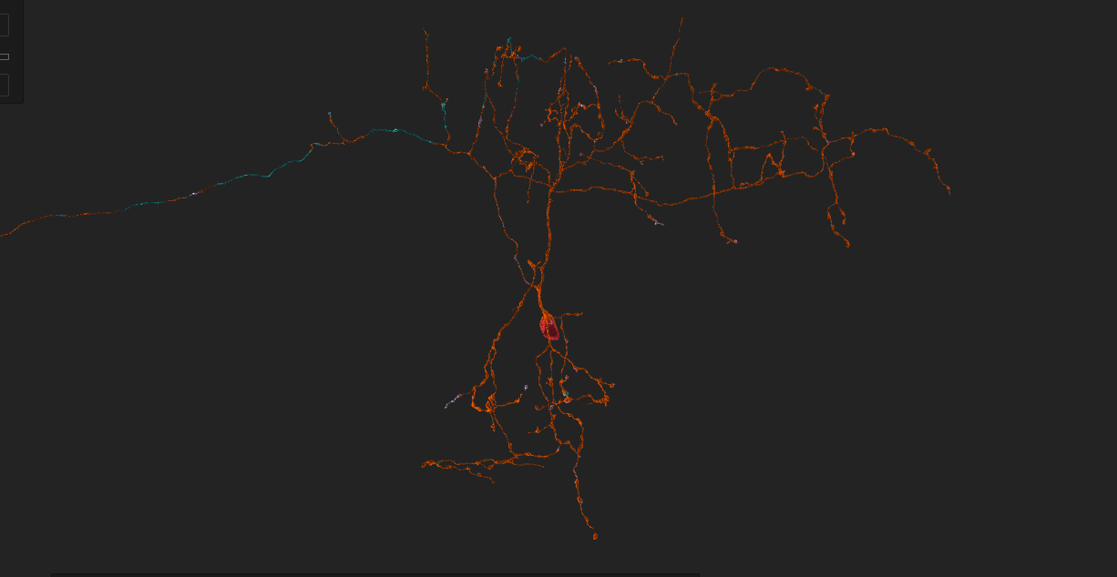

Here we have a large cell with all kinds of branches. Which one is the axon you might ask? Well from this picture we can assume that the top left and right processes are the axon. Minus the dendrite in between which we will cover later.

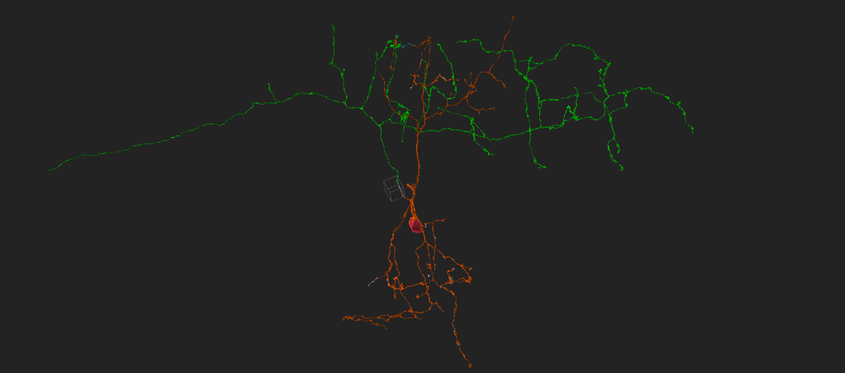

From this picture it is hard to see where the axon begins. Let’s take a closer look at the [axon hillock](https://en.wikipedia.org/wiki/Axon_hillock).

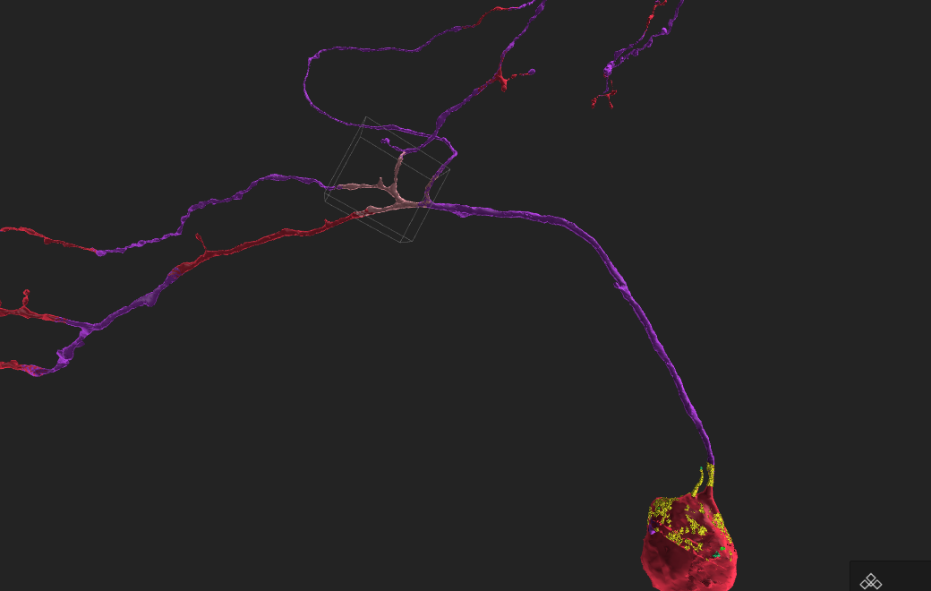

In this picture we can see the soma in the bottom right and a long process traveling upward that comes to a junction where several branches split off up and to the left. At this junction it is likely we will find the axon hillock.

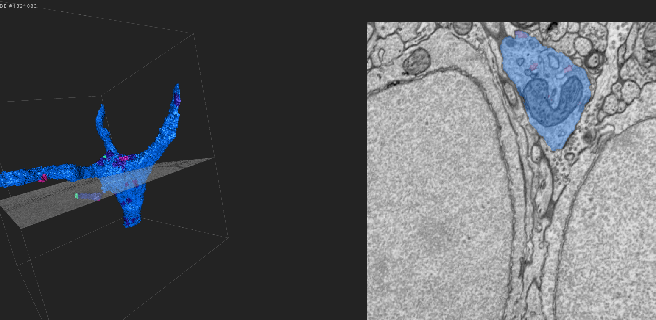

In this picture we can see a junction and the 2D where the hillock can be seen. The hillock is the origin of the axon. Its growth is usually accompanied by dendrites near the area as well. In this picture it looks like there is one axon and two dendrites with a small little spine.

Another way to identify an axon is by its morphological clues. Axons are usually long and spindly with bulbous boutons aka presynaptic sites. Each cell **only** has one axon. Though, that axon may be very long and split into multiple branches, there should only be one axon coming from the soma.

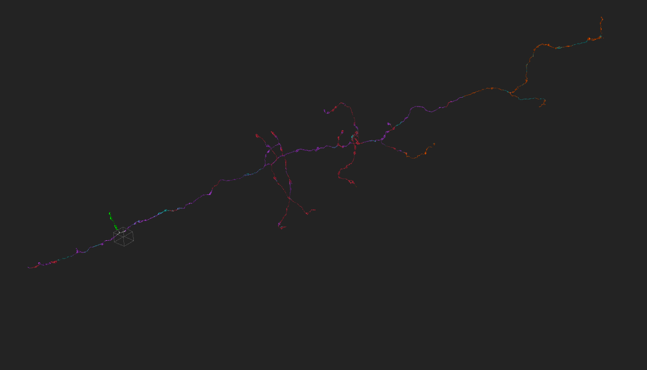

This is a picture of a cell in which the data set didn’t have enough information to incorporate a soma or any dendrites. This long neurite is entirely an axon.

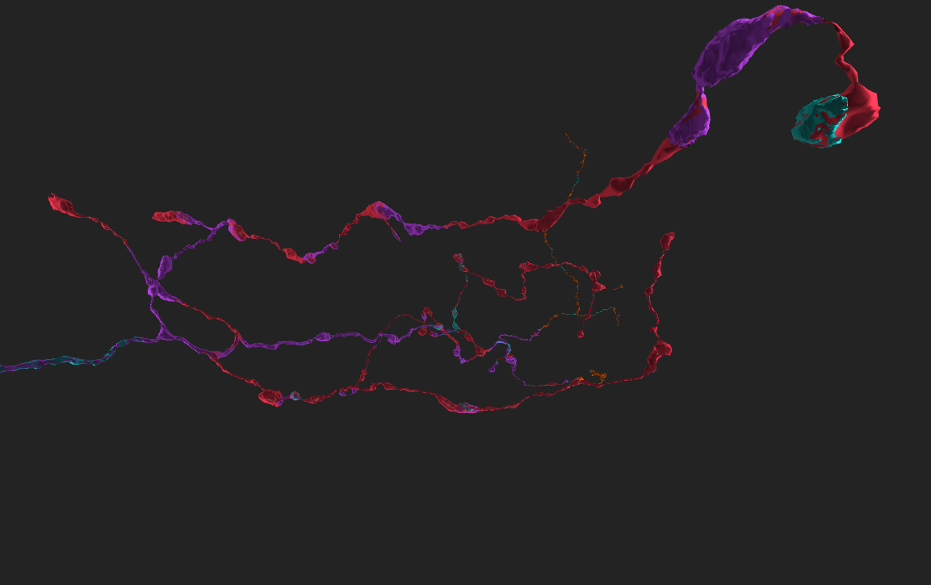

In this close up picture you can see the same axon and some of the [boutons](http://www.thefreedictionary.com/boutons).

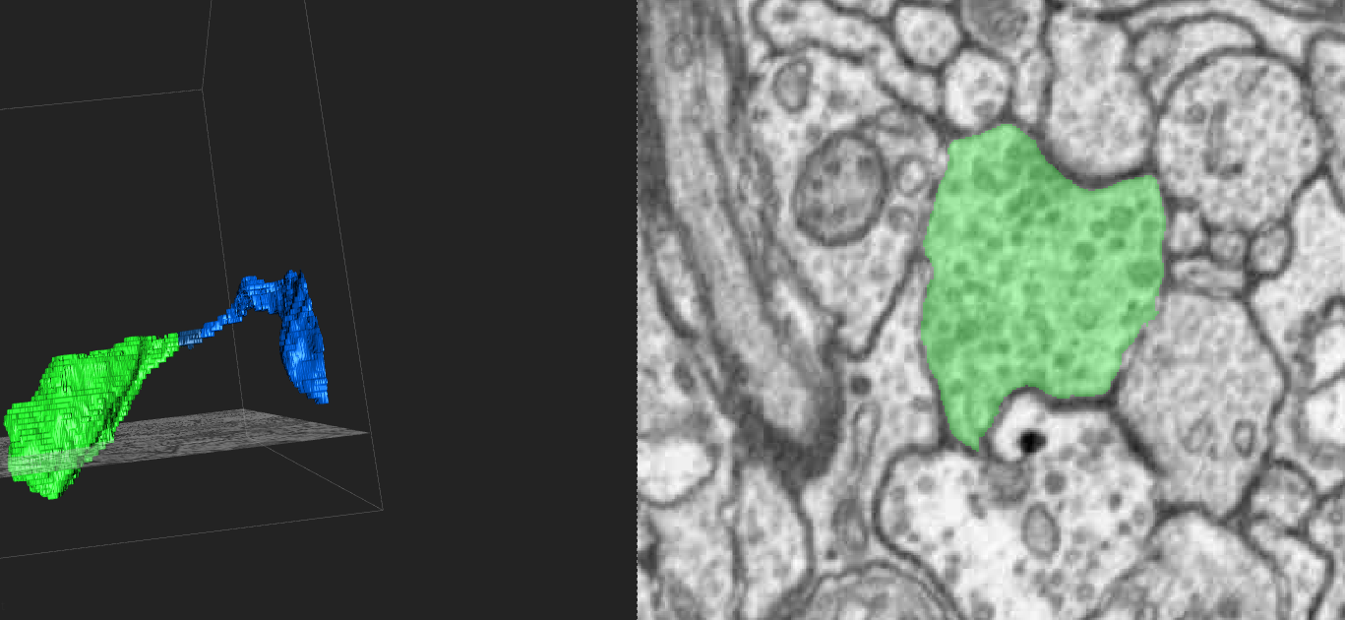

Here is a closer look at one of those boutons. Through the green segmentation you can see there are many little black and gray circles. These are the bouton [vesicles](https://en.wikipedia.org/wiki/Vesicle_(biology_and_chemistry)). A good tip when identifying neurites on the fly is to remember that **only** axons have these dense vesicle patches. Albeit hard to see there are also a few [synapses](https://en.wikipedia.org/wiki/Synapse). These vesicles and synapses are also great indicators when identifying neurites on the fly.

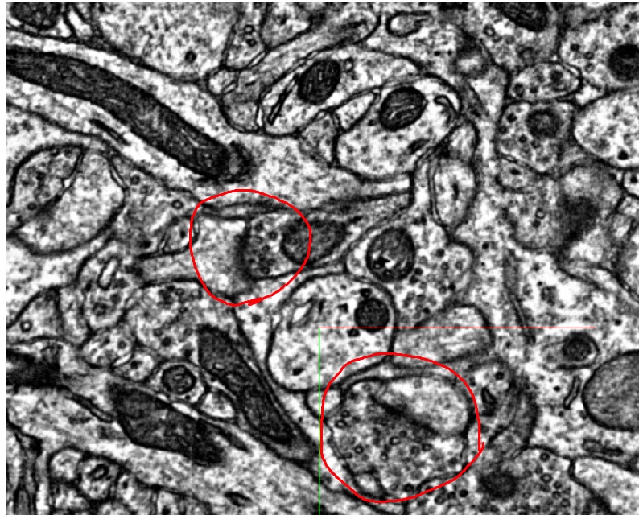

In this picture I can circled two synapses. From this you can tell that the neurites with vesicles are axons and the neurites without them are dendrites. The darker border between them is called the [postsynaptic density](https://en.wikipedia.org/wiki/Postsynaptic_density) aka PSD. Let’s take a look at the dendrites now.

#### Dendrite

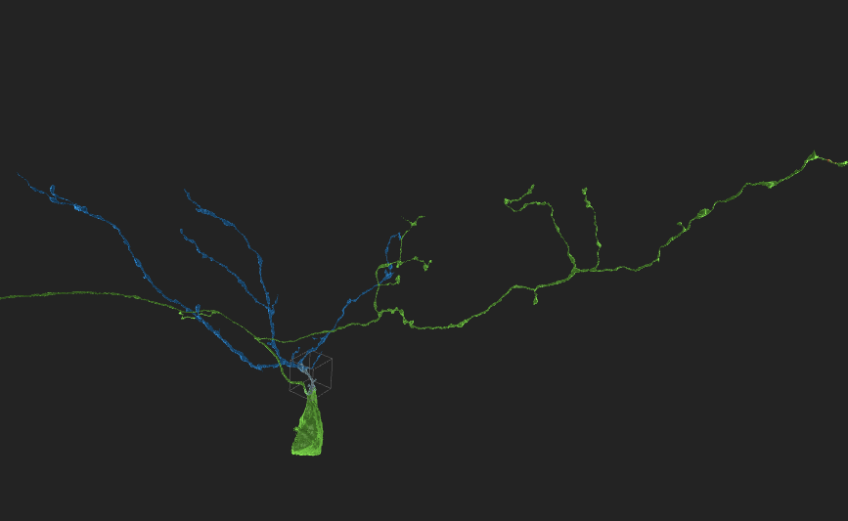

In this picture I have highlighted the [dendrite](https://en.wikipedia.org/wiki/Dendrite) in blue and the axon in green. (The soma is also green accidently.) The dendrite is going to be everything that is not the axon and soma. It often has many branches with lots of splitting sub branches and they typically end in spine heads - where the synapsing happens with other axons boutons.

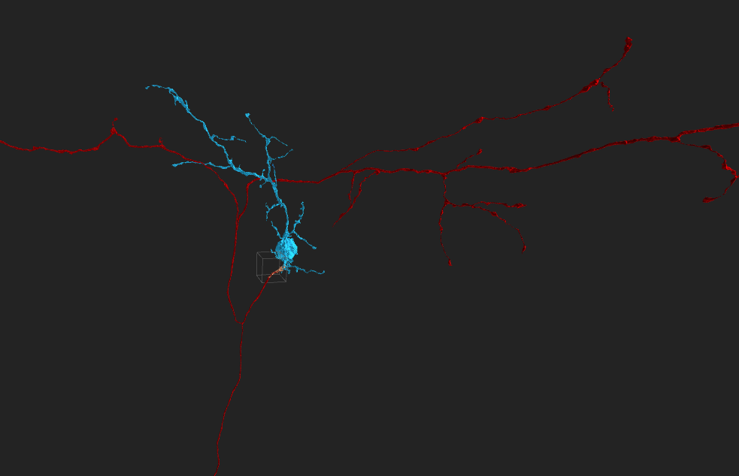

Here is another cell where the dendrite and soma are blue and the axon is red. In the next picture let’s take a look at spine heads.

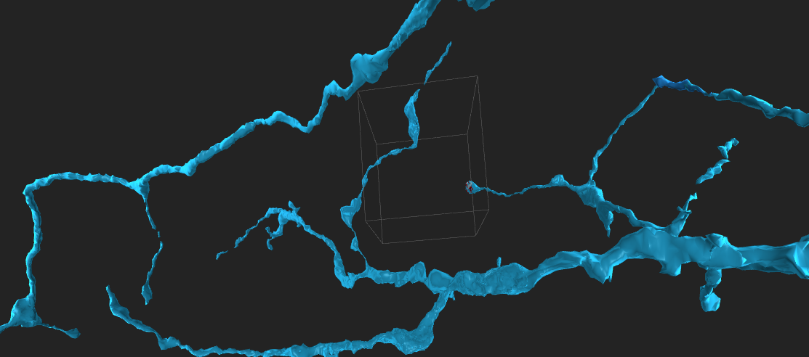

From this picture it is somewhat hard to determine just from the 3D if this is an axon or dendrite. Let’s take a look inside one of these processes and see if we can spot a synapse, some vesicles or both and use them to determine if we are dealing with a dendrite or an axon.

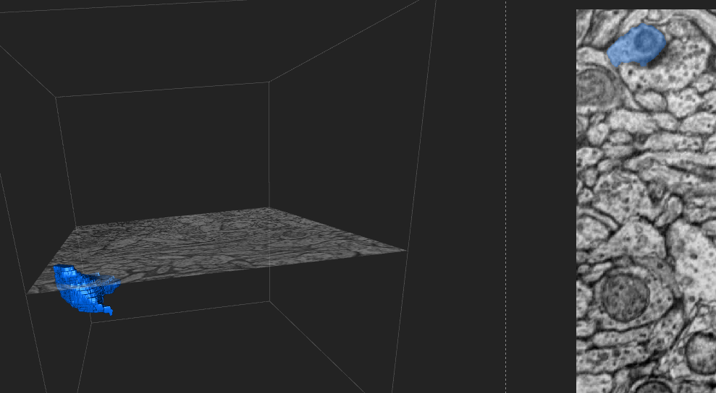

This is the end of one of the branches in the picture above it. From the looks of that 2D image we can see that our blue segment is a dendrite. We know this because it doesn’t have vesicles. There is also an axon next to it with vesicles and between the axon and our blue segment there is a PSD. We can then deduce that the blue segment is a dendrite that the near by segment is an axon synapsing with our dendrite. That’s pretty much the bare bones of what you’ll see in eyewire. There are other things inside the EM images like [myelin](https://en.wikipedia.org/wiki/Myelin) and [glia](https://en.wikipedia.org/wiki/Neuroglia). These things aren’t going to be traced at this time although you might run into them while you are tracing. If you want more information about them please check out the embedded links.

### Basic Controls

Inside a cube:

Left Click drag(on 3D)- rotate cube around center point

Right Click drag(on 3D)- pan cube

Shift + Left Click(on 3D)- create and move to new center point

Double Left Click(on 3D)- move to new slide (arrow key up and down also)

Right Click(On 3D and 2D)- delete segment

Hold down Ctrl(3D and 2D)- split all segments/suspend Msty threshold

Scroll wheel- scroll through slides (arrow key up and down also)

Ctrl + Scrollwheel- increase/decrease Msty threshold

Left Click (2D only)- fill in segment(s)

-drag to fill in across the slide

“Q” and “E” (2D only)- change brush size

MIddle button aka mouse button 3 drag (2D only)- pan slide (can be used in 3D)

Alt + scroll wheel (2D only)- zoom in/out

Space- zoom in on specific point in 2D

Hold down Shift (2D only)- temporarily turn off segmentation

Overview:

Left Click drag- rotate around center

Double Left Click- create and move to new center

Shift + left click- move to specific cube

MIddle button aka mouse button 3 for panning in the overview

Enter key to inspect a cube (a great way to move the camera to a far off cube is to enter it and then exit it)

Exit a cube with Escape key

‘F’ key freezes a cube

‘C’ key completes a cube

### Eyewire Expert Tips and Tricks

So as a tracer with the modern version of Eyewire, the process of our function should be to assist/correct Msty. From the above text, you know that when you start a cell, your first step should be to turn Msty on. From the seed cube, Msty will start to make connections. Watch these connections to approve or disapprove of Msty’s progress by correcting and assisting its growth. In terms of accuracy, Msty is pretty good, but it’ll often make mistakes either in the form of mergers, or by failing to continue to grow out a branch. This section will go over ways in which these obstacles should be handled by way of proven methods or workarounds.

**Trick One:** How to effectively tackle a merger.

**Turn off Msty and freeze all children**

To deal with a merger, whether created by Msty or by an Eyewire tracer, the very first step should be to make sure that Msty is turned off. By now you should be familiar with the location of the AI toggle button in the cell drop-down menu. With Msty turned off, we can work at a comfortable pace without worry that the merger will continue. Sometimes the merger will seemingly continue to spawn cubes even after Msty is turned off. To completely stop the spawning of cubes you can freeze cubes. The best way to ensure that all spawning cubes will stop spawning for the moment is to use the freeze all children command.

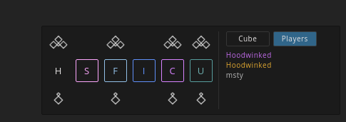

This is a picture of the the admin/scythe hot bar. The Button that has an ‘F’ in it is the freeze button. When selecting a cube in the overview if you hit ‘F’ then it will freeze the selected cube. If you hit the cluster of diamond shapes above the ‘F’ button it will freeze the selected cube and all of the cubes that spawned from that cube.

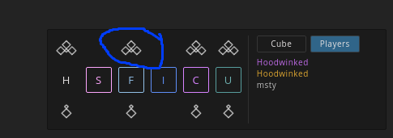

This will color the selected cube and all it’s children white to indicate to you that they are frozen and won’t spawn any more cubes.

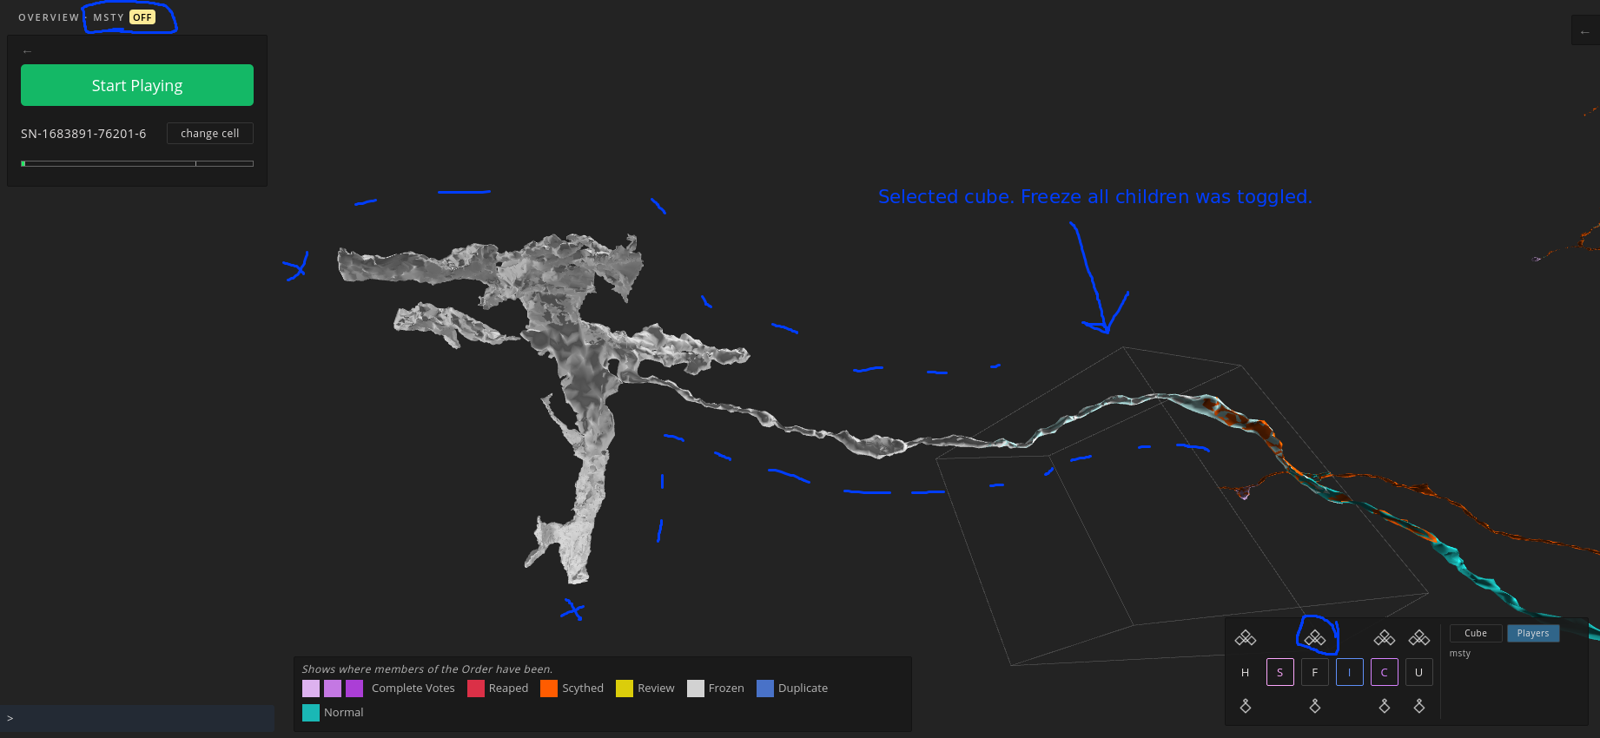

**Locate Merger Origin Cube and Remove Merger**

Next, we will want to locate the cube in which the merger originated. Here you’ll find the root of the merger which, once removed, will remove all merged children, effectively removing the merger entirely. A quick way of locating the root merger cube would be to click anywhere on the merged segment, and then to click the “Parent” text button at the bottom of the overview screen.

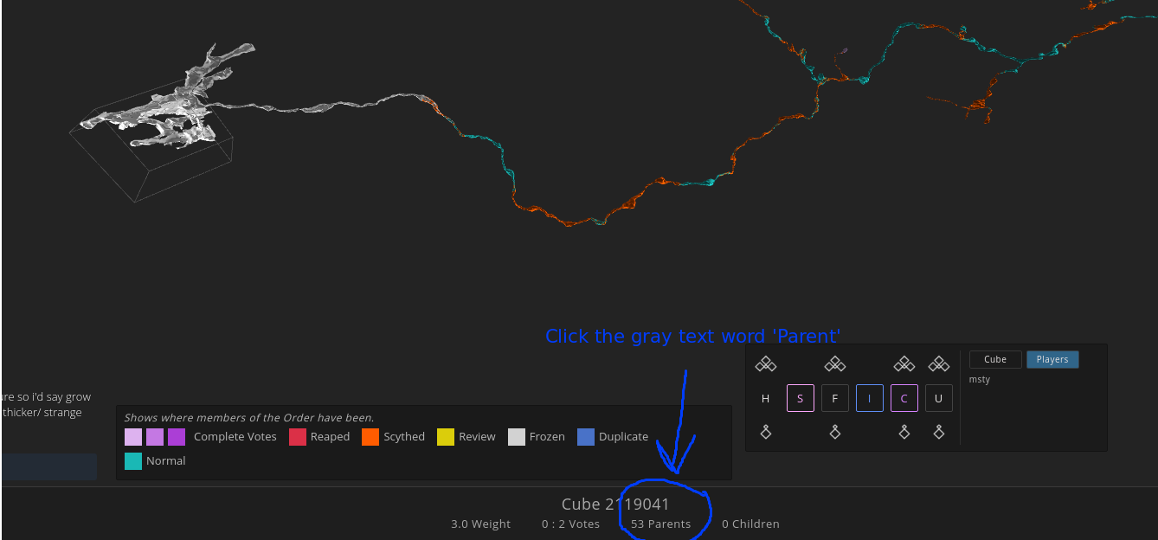

This will highlight every branch in every cube that came before the selected cube.

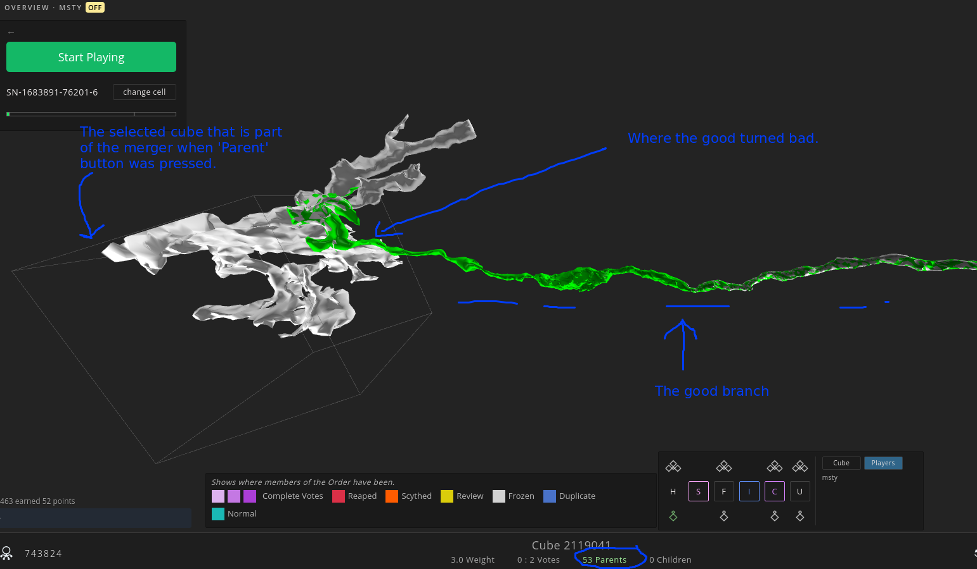

Take a look at where the highlighted merged branches meet the highlighted correct branch. Locating the origin point of the merger may take some practice but overall shouldn’t be difficult. Eventually you should be able to locate it without using the “Parent” button. Once you’ve found the cube, enter it and remove the merger, making sure that you are keeping the pieces that do belong in the cube.

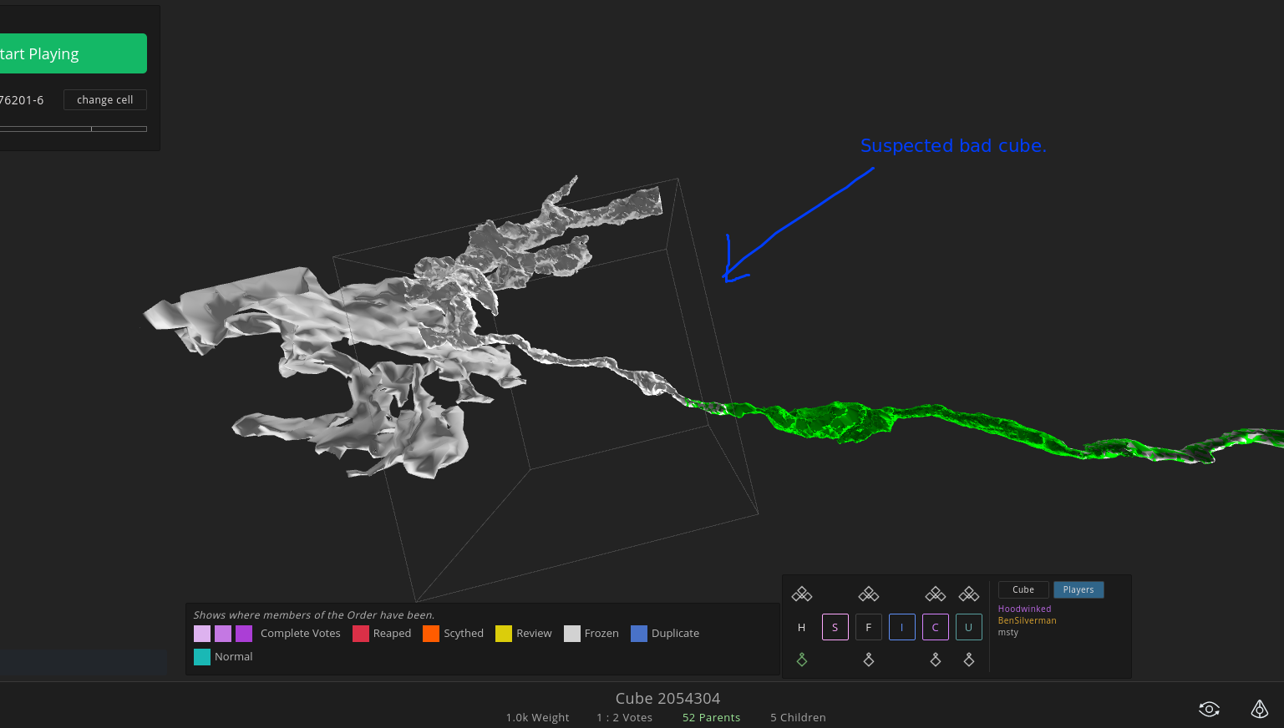

Every cube in which a merger originates contains correct pieces/branches and the incorrect pieces/branches. **It’s important that you don’t reap cubes empty**, so when removing merged pieces from a cube, you will want to make sure that you are leaving pieces that do belong.

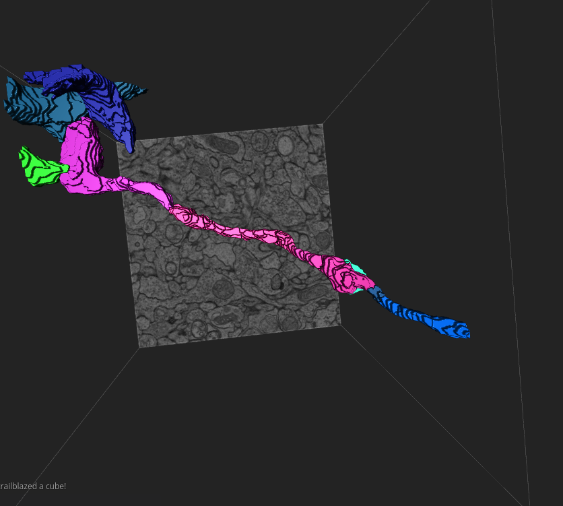

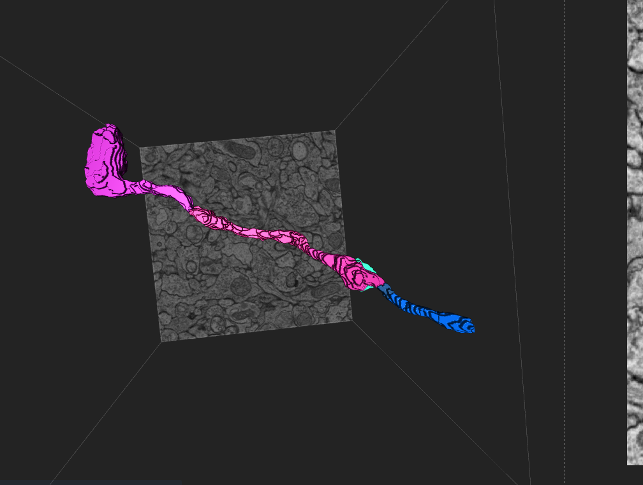

If the cube was frozen when you reap it clean to despawn the merger you will have to unfreeze the cube you reaped.

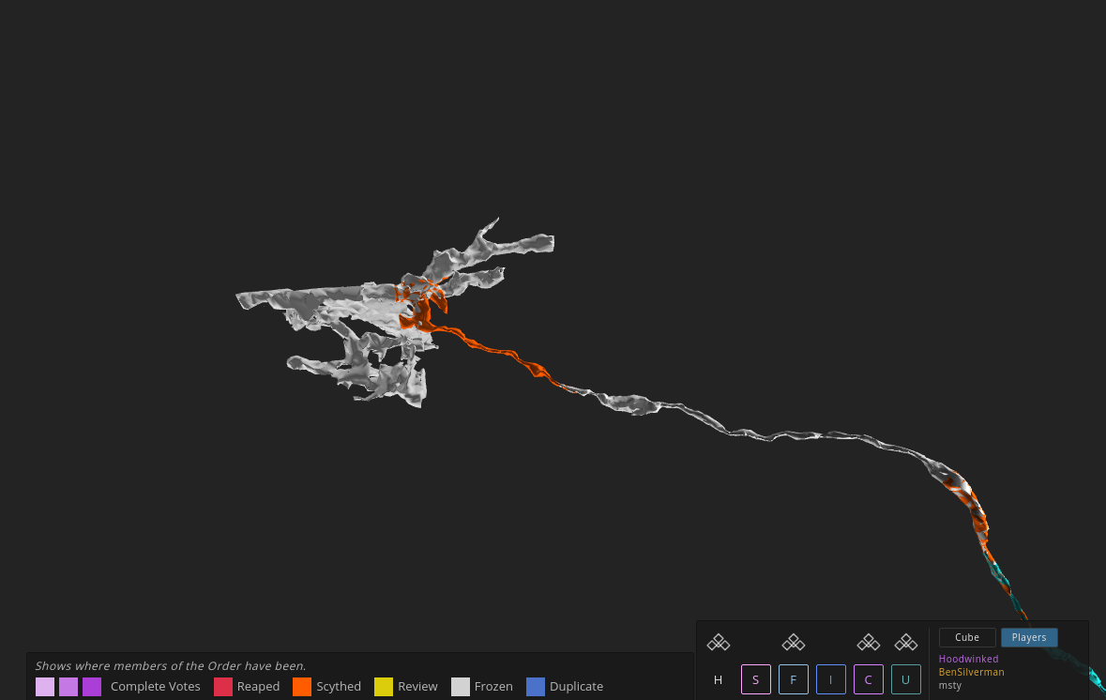

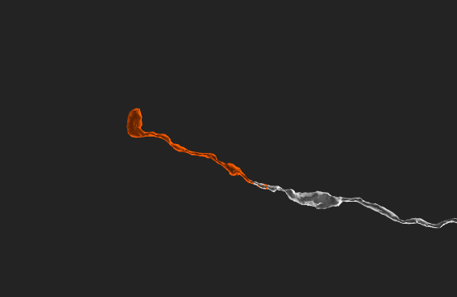

**What to watch out for**

When dealing with mergers it is possible for msty to spawn a cube that has nothing but the wrong segments in it. When this happens you will have to find the correct segment inside that cube without a functional seed piece. To help you locate the correct branch from the previous cube you will use the ‘Parent’ button. This will highlight the parent in orange and give you a clue of where the correct continuation is. This won’t always work so sometimes you will need to hop from cube to cube and use neuron landmarks to trace your path.

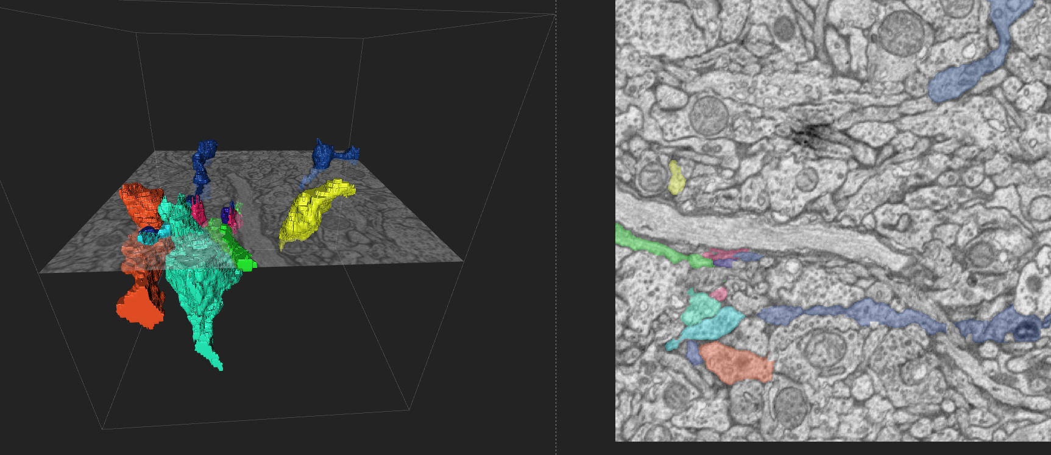

~~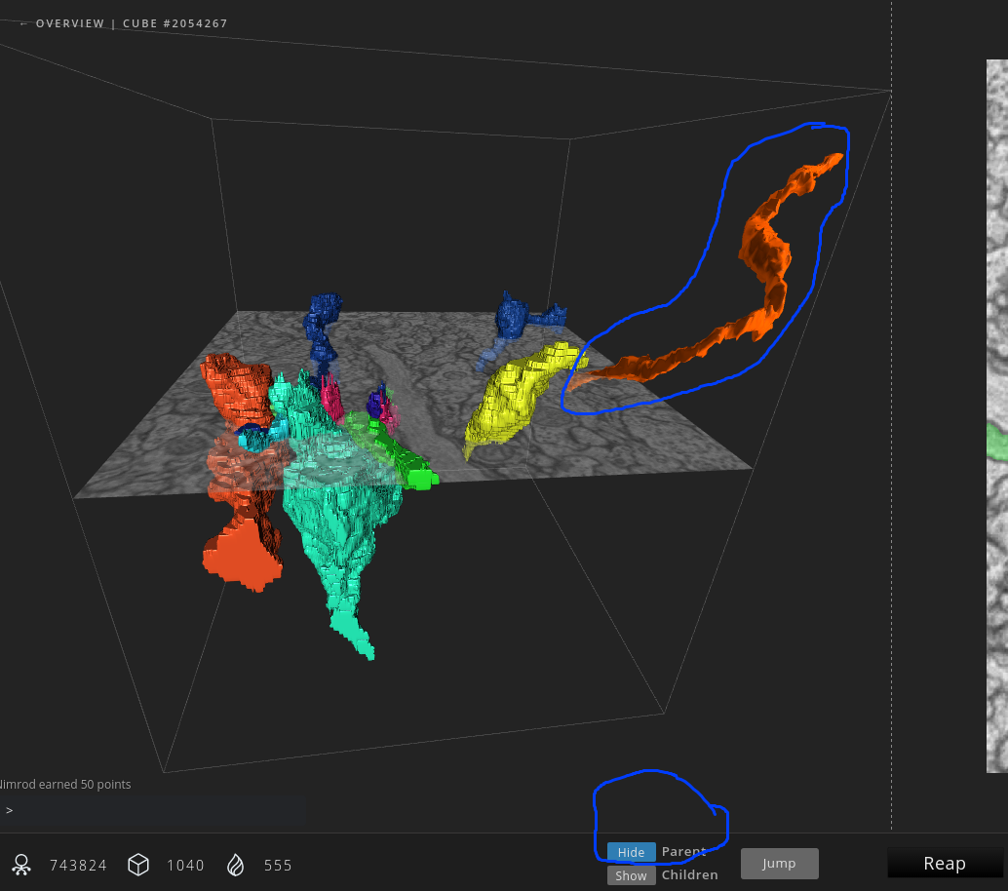~~

You will notice that the parent makes a segment but that segment is transparent. Haha xD

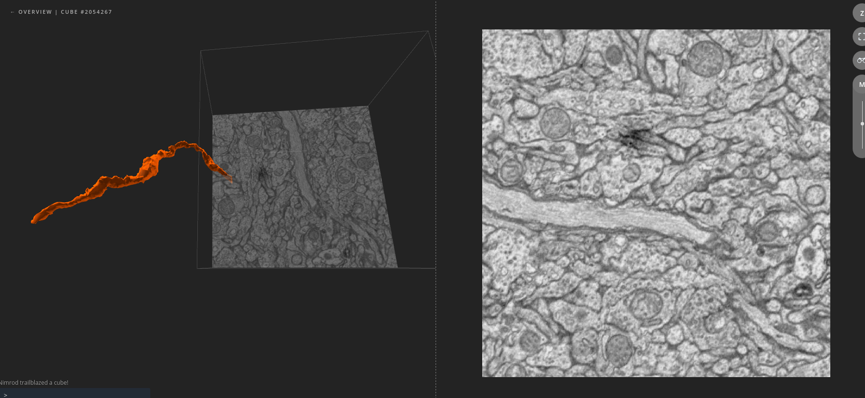

Using this transparent segment you can find the correct trace.

~~It may come to pass that when you enter the cube containing the original merged section, the merged and therefore incorrect pieces are the only pieces that show up in the cube, even though from the overview a section or sections of a correct branch should appear in the same space. This is a rendering issue, but it’s one that we have to take an extra step to correct. Hopefully this can be solved simply by clicking the Show Parent or Show Child buttons at the bottom of the in-cube screen and filling in the highlighted area that extends into the cube. As covered above, clicking these buttons will show you what came before and what comes after this cube respectively. We use this to give us more perspective. In this situation, where the pieces of a branch/branches that you wish to leave in the cube aren’t showing up, clicking on these buttons may show you where they would be within the cube, at which point all you would have to do is move the horizontal 2D plane to the corresponding sections of the cube highlighted by the “Show” function and fill them in.~~

**Plan B**

Use neuron landmarks from the previous cubes with correct traces. This is possible because each cube has one inch overlap with each other.

~~In the cases where clicking the Show Parent or Show Children buttons don’t show you where the correct branches lie within the cube, you would have to find the pieces or branches yourself. This can be a little tough. What we recommend is to exit the cube and enter a cube where the correct and desired branches ARE rendered. You would then have to memorize what the 2D image looks like where said branches lie, then return to the trouble cube and fill the branches in accordingly. Alternately, you can take a screenshot rather than memorizing.~~

~~One the merged pieces are reaped out of the origin cube, the merger in the overview should start to disappear.~~

**False Terminations**

A false termination simply means that the branch stopped spawning when it should have continued. The overview in Eyewire is expansive, but it isn’t limitless. Each cell ~~on display~~ on Eyewire exists ~~within its own unseen cube~~ within the limited space of the data set (stack of images also referred to as a cube). When branches reach the edge of this cube, they end with a smooth flat surface (or jagged like layers of slate stones usually accompanied by black space missing from the 2D images), ~~letting us know~~ indicating that a particular branch cannot continue. A nub or tip of a branch that doesn’t end in a spine head, soma, or axonal bouton and isn’t smooth, can be ~~indicative of a probable continuation.~~ a clue that you’ve found a false termination.

~~You may sometimes come across such a nub and desire to enter the cube to grow it out, but find that the last cube on the branch doesn’t extend beyond the tip of the branch. What I mean by this is that the tip you wish to grow out hits the edge of what seems to be the last cube along the branch. When this happens, the solution is to backtrack to find another cube or cube whose border extends beyond the tip of the branch.~~

Each cell in Eyewire is made of of overlapping cubes, often sharing much of the same space ~~and branches that exist within this space.~~ This is what usually causes these false terminations.

~~So when faced with this dilemma, it’s always a good idea to click along the branch to reveal an alternate cube that would allow for the continuation of the branch. Remember, Msty will do it’s best to grow branches on it’s own, but it often gets stuck and needs our intervention.This type of false termination can happen not just at the borders of cells, but really anywhere. Below are some images as example.~~

There are two types of false terminations.

In **Exhibit 1**, you can clearly see the edge of the selected cube. The selected section of the branch that pertains to this cube is highlighted a tan/beige color. **Object A** is a branch that ends with a smooth surface, indicating that a border is what has prevented it from continuing to grow. Since there are branches on either side of **Object A**, we can be sure that this false stop is not the result of the branch reaching the end of the overall cell cube, but rather the result of it reaching the end of the individual cube. To continue to grow this branch out, the usual method would be to select the farthest portion of the branch, whose cube would ideally extend the farthest, allowing room for growth. In this case however, the farthest point of the branch is already selected and we are met with a border that ends with the branch.

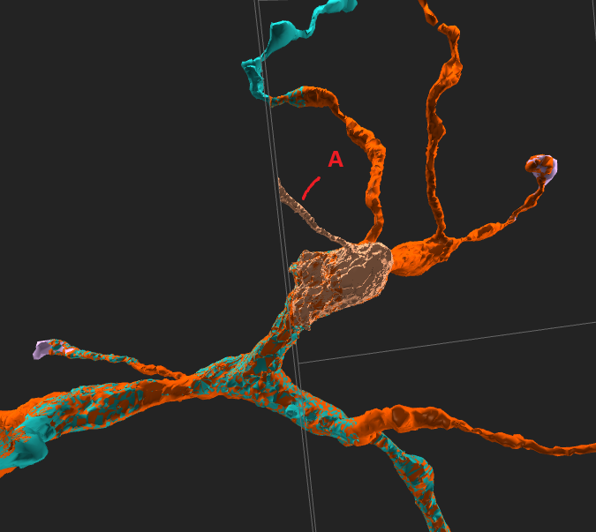

*Exhibit 1*

In **Exhibit 2**, I have selected a different section of the branch and therefore a different cube. The selected section is highlighted tan/beige, and you can see that it’s border extends beyond the false end of the branch in question. By entering this cube, I can continue the growth of said branch. The reason the branch didn’t continue on it’s own was because the player reaped the cube that it would have spawned into before it had time to grow. Without realising it the player set in stone that cube making it impossible for the cube to spawn anything there because a human player already reaped what was ‘supposed’ to be there leaving out that small branch.

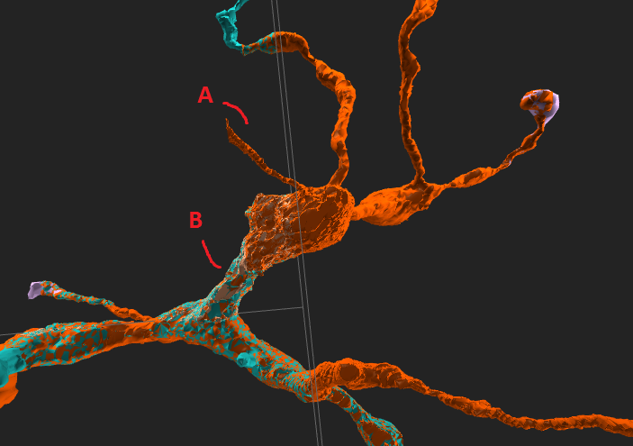

*Exhibit 2*

**Exhibit 3** shows what is contained in the cube selected from **Exhibit 2**. The only section that appears is of the branch marked **Object B** in **Exhibit 2**. The branch that we wish to continue, **Object A**, is not present even though in the overview it is included in the cube as seen in **Exhibit 2**. At this point, we have to locate **Object A** in the 2D of this cube and fill it in ourselves. We can use the cube from **Exhibit 1** as reference. By re-entering the cube in **Exhibit 1** we can see what **Object A** looks like in the 2D, and can either memorize its location or take a picture of it to use to locate **Object A** in the cube shown in **Exhibit 2**.

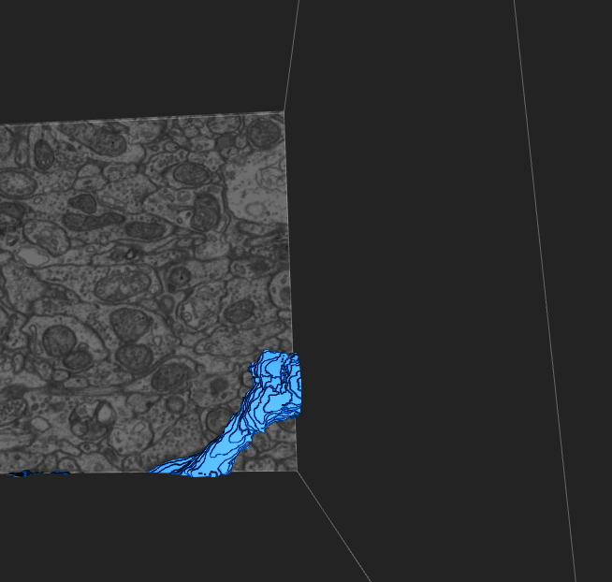

*Exhibit 3*

**Exhibit 4** shows what the area looks like in the overview, once the branch has been successfully extended.

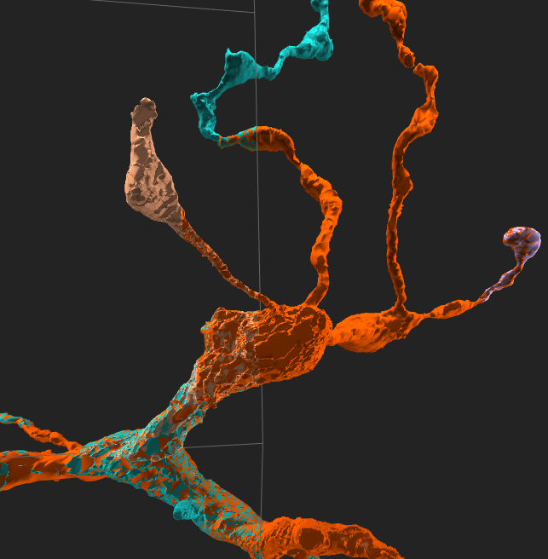

*Exhibit 4*

**Dutch Tracing**

Deriving it’s name from a joke on Dust Tracing, Dutch Tracing is (done when there is no reason that the a new cube isn’t spawning, or you can’t click any correct segmentation to continue) the process of intentionally by spawning a cube from an incorrect piece in order to further the ~~patch of~~ a desired branch. Sometimes while working in Eyewire, you might find that a branch that you are growing out reaches the end of a cube, but is unable to be colored in/clicked on. This might be due to an image issue, or because the branch becomes too pinched and small for our click to register. This can be frustrating because you can clearly see that the branch continues into the next cube, but without an edge piece, the next cube will not spawn (sometimes even with an edge piece). The remedy for this is to click a different edge piece near the desired piece, and temporarily reap it as part of the cube. This will spawn the next cube that we need to continue the desired branch. **Note:** Before proceeding with this method, it is a good idea to first **turn Msty off**. In the example video below, you can see that I cannot continue the branch past the teal piece (Notice the flashing of the cursor indicating fruitless clicking). What I do instead is click on the nearby green edge piece, and then reap it in. Once I return to the overview, I select the once green edge piece and enter it’s cube. Once inside, I use the Show Parent button on the bottom of the screen to help me relocate the desired branch. Once located, I remove the nearby edge piece that I used to access this cube, and then continue to grow out the desired branch.

**Clean Up:** Remember that the edge piece or “Dutch piece” that I originally reaped in as a way to access the next cube will stay as part of the branch unless it is removed from the cube it was originally reaped in.

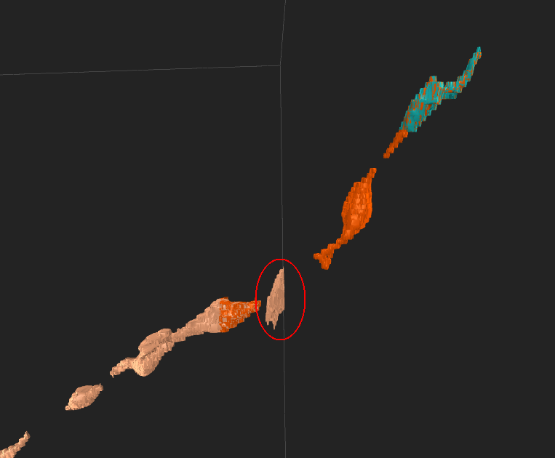

In this example I must return to earlier cube (selected in the picture above) and remove the circled piece in order for it to disappear. (sometimes you will have to leave in the wrong piece for it to keep the branch there.)

### Filling in somas:

Before the cell can be finished, each piece of the soma has to be fully filled in. Go through each part of the soma and fill in missing pieces of dust or missed connections. If the threshold is set high, the massive amount of individual segments will slow eyewire down and it will be harder to find the missing dust. Set the threshold at its lowest and scroll through to find missing pieces. Before you fill them in, hold ‘CTRL’ to temporarily break up the segments. If you try to fill in a piece of dust with the threshold set low it will likely create large mergers and undo any progress.

Watch out for mergers when the threshold is set low. If you create a merger, then try and use the undo function by pressing CTRL + Z, it will take out the segment you filled in last along with any segments that fused with it at the current threshold. In other words, using the undo function won’t necessarily take you a step backward, as it would in photoshop. Unfortunately, there is no history log. To avoid frustration

### **Duplicate Cubes**

A duplicate cube is one that shares the same super voxel with a cube in a different cell. A super voxel is a 3D pixel referred to sometimes as a ‘piece’ or a ‘segment’. A duplicate happens when msty or a player spawns/reaps in, one or many super voxels that already belong to another cell. To fix the duplicate a player must figure out which cell the super voxel(s) belong to. Duplicate voxels will show up as Orange when you inspect the cube. The duplicate cube will be highlighted Blue in the overview and will no longer spawn new cubes. < Insert Pic >

When a cube turns duplicate it will have an extra button when you inspect it. The button will be near the ‘D. Trace’ and ‘D. Seed’ button. <Insert Pic>

This new button is for switching between the duplicated cubes. A cube will stop being a duplicate when you remove all the duplicate super voxel(s) from one of the cubes. After that is finished it will be like any other cube again.